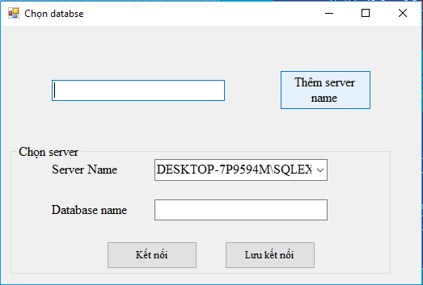

|  |  |  |  |
| --- | --- | --- | --- |
| STT | Tên | Kiểu | Ý nghĩa |
|  | … | Textbox | Nhập tên cơ sở dữ liệu |
|  |  |  |  |
|  |  |  |  |

|  |
| --- |
| Chọn database |
|  |
| void btn_addsvname_Click(object sender, EventArgs e)  void button1_Click(object sender, EventArgs e)  void btn_saveconnect_Click(object sender, EventArgs e) |

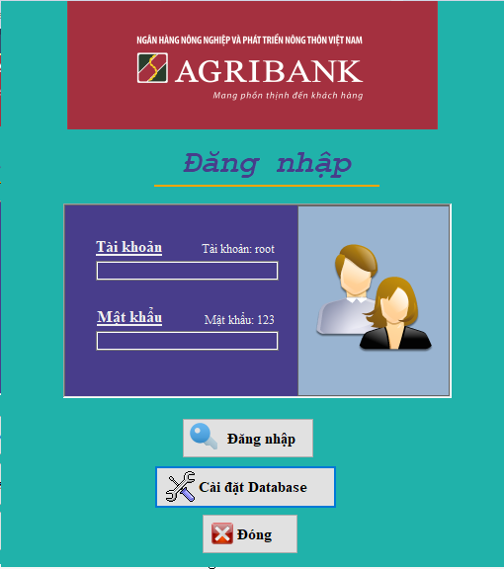

|  |
| --- |
| Đăng nhập |
|  |
| void btn_login_Click(object sender, EventArgs e)  void btn_setdb_Click(object sender, EventArgs e)  void btn_close_Click(object sender, EventArgs e) |

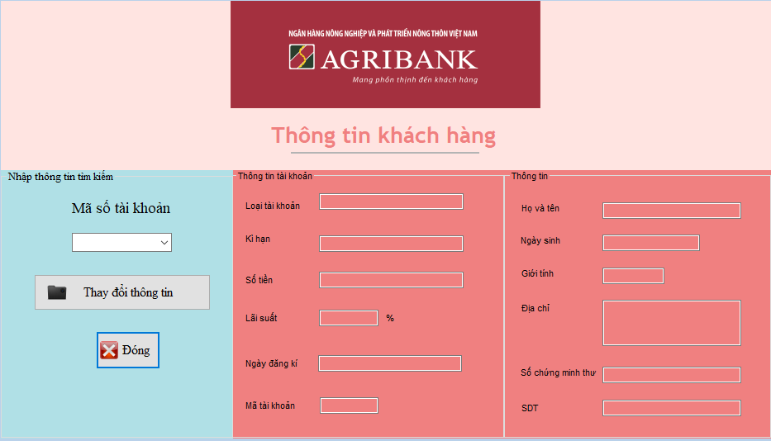

|  |
| --- |
| Thông tin khách hàng |
|  |
| void button1_Click_1(object sender, EventArgs e)  void button3_Click(object sender, EventArgs e)  void check_account_Load(object sender, EventArgs e)  void CapNhat()  void comboBox1_SelectedIndexChanged(object sender, EventArgs e) |

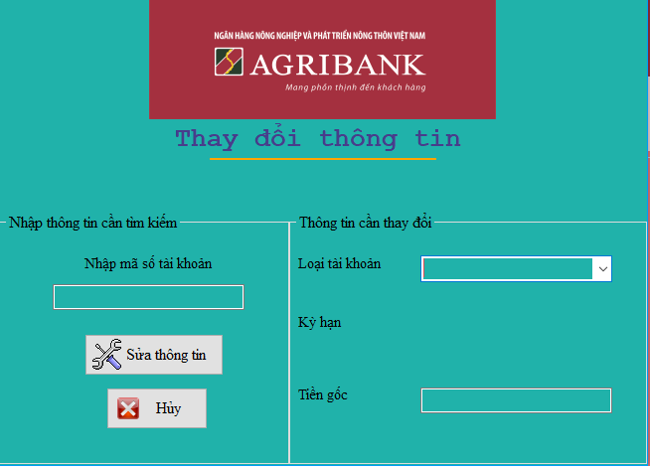

|  |
| --- |
| Thay đổi thông tin |
|  |
| void btn_changeinfo_Click(object sender, EventArgs e)  void button2_Click(object sender, EventArgs e)  void cbx_typecustomer_SelectedIndexChanged(object sender, EventArgs e) |

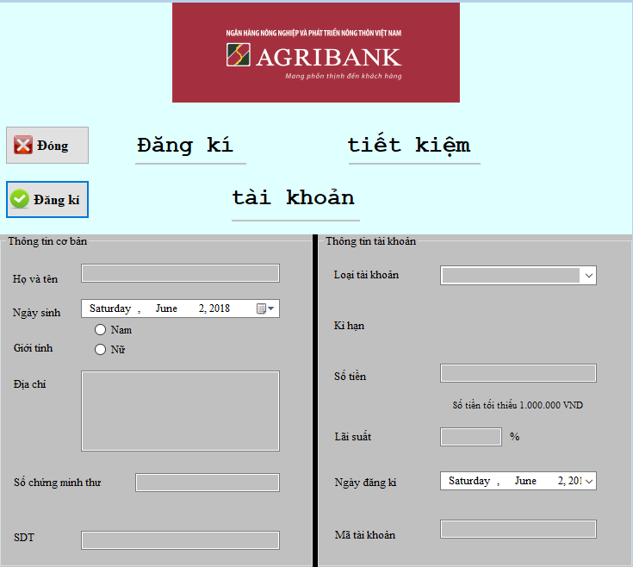

|  |
| --- |
| Đăng kí – Tài khoản |
|  |
| void button1_Click(object sender, EventArgs e)  void button2_Click(object sender, EventArgs e)  void ckb_male_CheckedChanged(object sender, EventArgs e)  void ckb_female_CheckedChanged(object sender, EventArgs e)  void cbx_typecustomer_SelectedIndexChanged(object sender, EventArgs e)  void txt_typecustomer2_SelectedIndexChanged(object sender, EventArgs e)  void radioButton1_CheckedChanged(object sender, EventArgs e)  void radioButton2_CheckedChanged(object sender, EventArgs e) |

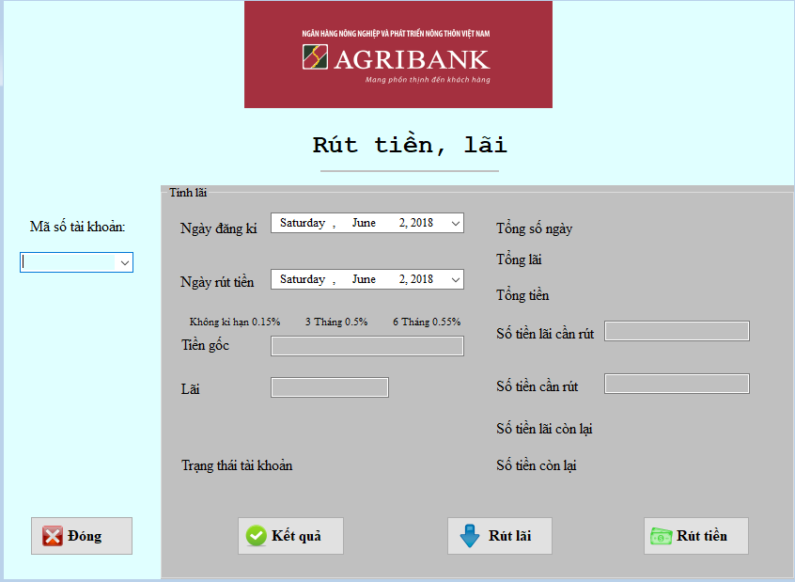

|  |
| --- |
| Rút tiền, lãi |
| + DateTime date1  + DateTime date2  + string daydate  + string xxx  + double xyz  + double money1  + double money2  + double tienlai  + double tientong  + double tienlaicr  + double tienlaicl  + double tienttk  + double sum  + double tiencl  + double tiendc |
| void ruttien_lai_Load(object sender, EventArgs e)  void CapNhat()  void btn_result_Click(object sender, EventArgs e)  void btn_getprofit_Click(object sender, EventArgs e)  void btn_getmoney_Click(object sender, EventArgs e)  void comboBox1_SelectedIndexChanged(object sender, EventArgs e)  void btn_close_Click(object sender, EventArgs e) |